List View Builder:

Now that we have successfully configured our home screen and the loading screen, we’ll now look at building the choose location screen. We’re going to create a list of cities which the user can choose from in order to display the time. We’ll come to our location_choose.dart file. Here first we’ll create a list, which stores objects of the WorldTime class. Each object here will be a new instance of the WorldTime class, having different ‘location’, ‘flag’, ‘url’ properties. This therefore is a ‘list of objects’ which we’ll display to the user:

List <WorldTime> locations=[  
 WorldTime(location: **'Kolkata'**,flag: **'india.png'**,url: **'Asia/Kolkata'**),  
 WorldTime(location: **'London'**,flag: **'uk.png'**,url: **'Europe/London'**),  
 WorldTime(location: **'Berlin'**,flag: **'germany.png'**,url: **'Europe/Berlin'**),  
 WorldTime(location: **'Cairo'**,flag: **'egypt.png'**,url: **'Africa/Cairo'**),  
 WorldTime(location: **'Nairobi'**,flag: **'kenya.png'**,url: **'Africa/Nairobi'**),  
 WorldTime(location: **'Chicago'**,flag: **'usa.png'**,url: **'America/Chicago'**),  
 WorldTime(location: **'New York'**,flag: **'usa.png'**,url: **'America/New_York'**),  
 WorldTime(location: **'Seoul'**,flag: **'south_korea.png'**,url: **'Asia/Seoul'**),  
 WorldTime(location: **'Jakarta'**,flag: **'indonesia.png'**,url: **'Asia/Jakarta'**),  
 WorldTime(location: **'Denver'**,flag: **'usa.png'**,url: **'America/Denver'**),  
 WorldTime(location: **'Tokyo'**,flag: **'japan.png'**,url: **'Asia/Tokyo'**),  
 WorldTime(location: **'Rio De Janeiro'**,flag: **'brazil.png'**,url: **'America/Argentina/La_Rioja'**),  
 WorldTime(location: **'Helsinki'**,flag: **'finland.png'**,url: **'Europe/Helsinki'**),  
 WorldTime(location: **'Oslo'**,flag: **'norway.png'**,url: **'Europe/Oslo'**),  
 WorldTime(location: **'Lisbon'**,flag: **'portugal.png'**,url: **'Europe/Lisbon'**),  
 WorldTime(location: **'Stockholm'**,flag: **'sweden.png'**,url: **'Europe/Stockholm'**)  
];

Till now we know one way of generating a list, and that is using the map() function. There is another way of doing so using a different method, and the widget is called the Listview.builder. It takes in 2 properties.

1. The itemCount, which specifies the number of items in the list. (We’ll pass in the length of the list ‘locations’ here)
2. The itemBuilder, which takes in a function as the value.

This function is the one which we want to execute for each item in the list. This function takes in 2 parameters:

1. The context object
2. The index of the current object (it is automatically passed when the builder accesses new elements of the list).

This function in the itemBuilder will build a widget tree for each element in the list (a card for example). Each time we fire this function, we get access to each new element in the list, and we make a card for that element. This card is then appended to the ListView which is built by this builder. We add some padding to our cards. We’ll also display the respective flags of the countries in our card. This is where the ‘flag’ property comes into play. We’ll place a listTile widget as the child inside our card. A brief description of the listTile can be found [here](https://youtu.be/l8dj0yPBvgQ). Read more [here](https://api.flutter.dev/flutter/material/ListTile-class.html).

Each listTile also comes with an onTap property, which we’ll leave blank for now. We’ll display the flag of the country on the leading end of our listTile. Our final function looks like:

body: ListView.builder(  
 itemCount: locations.**length**,  
 itemBuilder: (context,index){  
 **return** Padding(  
 padding: **const** EdgeInsets.symmetric(vertical: 1.0,horizontal: 4.0),  
 child: Card(  
 child: ListTile(  
 onTap: (){  
 },  
 title: Text(locations[index].**location**),  
 leading: CircleAvatar(  
 backgroundImage: AssetImage(**'assets/**${locations[index].**flag**}**'**),  
 ),  
  
 ),  
 ),  
 );  
 },  
),

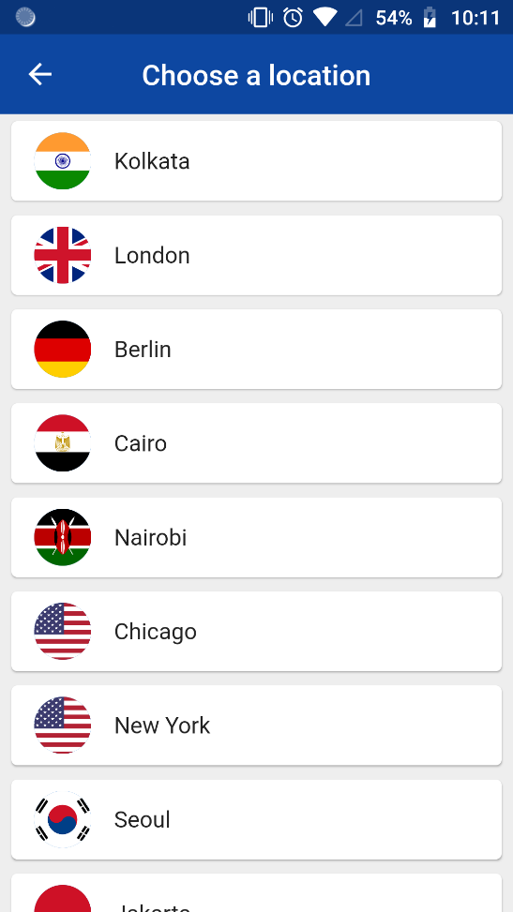 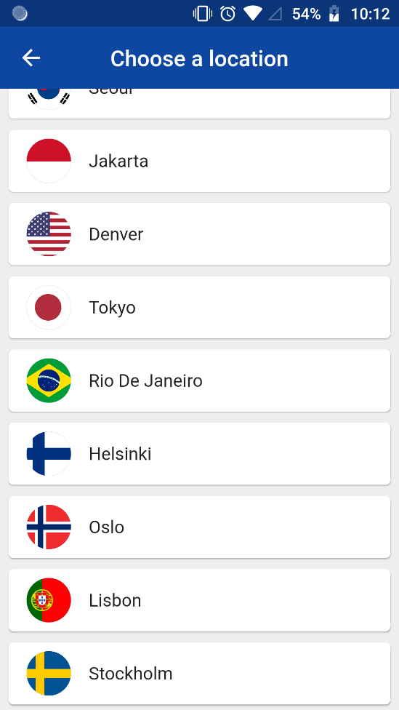

Now that we have our list created, we need to switch back to the home screen with the updated time whenever the user taps on a city. For this we shall create a function in the location_choose.dart file called updateTime, which gets called when the user taps on a city. Thus, we call this function in the onTap property of the listTile.

This function takes in the index of the location list as the parameter. This will again be an asynchronous function as it again has to query the worldTime API for the time of the newer city that the user has tapped on. Thus the getTime function needs to be called.

We first create a local variable which is an object of the WorldTime class. This will be instance which will store the properties of the new city.

**void** updateTime(index) **async**{  
 WorldTime instance=locations[index];  
 **await** instance.getTime();

}

After doing this, we need to navigate to the home screen. Normally, we would push the home screen on top, but remember! We have already pushed this screen on top of the home screen. Thus, the home screen is still sitting underneath this. In order to reveal the home screen, we need to remove or ‘pop’ this location_change route from the screen.

Navigator.*pop*();

While popping to the home screen, we also need to send this newly obtained data of the newer city. In order to do so, we need to pass in the context object, and the map of data. Remember, this time we DO NOT NEED TO SPECIFY THIS MAP IN AN ARGUMENTS PROPERTY.

Navigator.*pop*(context,{  
 **'location'**:instance.**location**,  
 **'time'**:instance.**time**,  
 **'flag'**:instance.**flag**,  
 **'eventOfDay'**:instance.**eventOfDay**,  
 **'url'**:instance.**url**});

Thus, our function looks like:

**void** updateTime(index) **async**{  
 WorldTime instance=locations[index];  
 **await** instance.getTime();  
  
 *//navigate to the home screen* Navigator.*pop*(context,{  
 **'location'**:instance.**location**,  
 **'time'**:instance.**time**,  
 **'flag'**:instance.**flag**,  
 **'eventOfDay'**:instance.**eventOfDay**,  
 **'url'**:instance.**url** });  
}

Our entire location_choose. Dart file looks like:

**import 'package:flutter/material.dart'**;  
**import 'package:chronograph/services/world_time.dart'**;  
  
**class** ChooseLocation **extends** StatefulWidget {  
 @override  
 _ChooseLocationState createState() => _ChooseLocationState();  
}  
  
**class** _ChooseLocationState **extends** State<ChooseLocation> {  
 @override  
 Widget build(BuildContext context) {  
  
 List <WorldTime> locations=[  
 WorldTime(location: **'Kolkata'**,flag: **'india.png'**,url: **'Asia/Kolkata'**),  
 WorldTime(location: **'London'**,flag: **'uk.png'**,url: **'Europe/London'**),  
 WorldTime(location: **'Berlin'**,flag: **'germany.png'**,url: **'Europe/Berlin'**),  
 WorldTime(location: **'Cairo'**,flag: **'egypt.png'**,url: **'Africa/Cairo'**),  
 WorldTime(location: **'Nairobi'**,flag: **'kenya.png'**,url: **'Africa/Nairobi'**),  
 WorldTime(location: **'Chicago'**,flag: **'usa.png'**,url: **'America/Chicago'**),  
 WorldTime(location: **'New York'**,flag: **'usa.png'**,url: **'America/New_York'**),  
 WorldTime(location: **'Seoul'**,flag: **'south_korea.png'**,url: **'Asia/Seoul'**),  
 WorldTime(location: **'Jakarta'**,flag: **'indonesia.png'**,url: **'Asia/Jakarta'**),  
 WorldTime(location: **'Denver'**,flag: **'usa.png'**,url: **'America/Denver'**),  
 WorldTime(location: **'Tokyo'**,flag: **'japan.png'**,url: **'Asia/Tokyo'**),  
 WorldTime(location: **'Rio De Janeiro'**,flag: **'brazil.png'**,url: **'America/Argentina/La_Rioja'**),  
 WorldTime(location: **'Helsinki'**,flag: **'finland.png'**,url: **'Europe/Helsinki'**),  
 WorldTime(location: **'Oslo'**,flag: **'norway.png'**,url: **'Europe/Oslo'**),  
 WorldTime(location: **'Lisbon'**,flag: **'portugal.png'**,url: **'Europe/Lisbon'**),  
 WorldTime(location: **'Stockholm'**,flag: **'sweden.png'**,url: **'Europe/Stockholm'**)  
 ];  
  
 **void** updateTime(index) **async** {  
 WorldTime instance=locations[index];  
 **await** instance.getTime();  
  
 *//navigate to the home screen* Navigator.*pop*(context,{  
 **'location'**:instance.**location**,  
 **'time'**:instance.**time**,  
 **'flag'**:instance.**flag**,  
 **'eventOfDay'**:instance.**eventOfDay**,  
 **'url'**:instance.**url** });  
 }  
  
 **return** Scaffold(  
 backgroundColor: Colors.*grey*[200],  
 appBar: AppBar(  
 backgroundColor: Colors.*blue*[900],  
 title: Text(**'Choose a location'**),  
 centerTitle: **true**,  
 elevation: 0,  
 ),  
 body: ListView.builder(  
 itemCount: locations.**length**,  
 itemBuilder: (context,index){  
 **return** Padding(  
 padding: **const** EdgeInsets.symmetric(vertical: 1.0,horizontal: 4.0),  
 child: Card(  
 child: ListTile(  
 onTap: (){  
 updateTime(index);  
 },  
 title: Text(locations[index].**location**),  
 leading: CircleAvatar(  
 backgroundImage: AssetImage(**'assets/**${locations[index].**flag**}**'**),  
 ),  
  
 ),  
 ),  
 );  
 },  
 ),  
 );  
 }  
}

In our home screen however, we are updating our UI inside the build function. This means that UI will be changed with the new data only when the widget tree is rebuilt. But we’re not re-building the widget tree, are we? We’re just popping from a different route. Thus, we need to figure out a way to rebuild the widget tree once we return from the location_choose screen. And how do we rebuild a widget tree? Of course! Using the setState function.

We can view the whole act of going to the choose_location screen, choosing a location, and then returning back to the home screen as ONE SINGLE ASYNC TASK. Thus we use the ‘await’ keyword before the pushNamed method on the home screen so that nothing changes until we get back from the choose_location screen.

After choosing the location, we don’t really know what kind of result this async task will return. Therefore we store it in a variable called ‘result’ whose datatype is ‘dynamic’. After returning from the choose_location screen, the map that we passed after popping, will be stored in ‘result’.

FlatButton.icon(  
 onPressed: () **async**{  
 **dynamic** result =**await** Navigator.*pushNamed*(context, **'/location'**);

}

…

Now we have the map in the result variable. Now, we can rebuild the widget tree by calling the setState function, and updating the value of the ‘data’ variable.

FlatButton.icon(  
 onPressed: () **async**{  
 **dynamic** result =**await** Navigator.*pushNamed*(context, **'/location'**);  
 setState(() {  
 **data**={  
 **'time'**:result[**'time'**],  
 **'location'**: result[**'location'**],  
 **'flag'**:result[**'flag'**],  
 **'eventOfDay'**:result[**'eventOfDay'**],  
 **'url'**:result[**'url'**]  
 };  
 });  
 },  
 icon: Icon(  
 Icons.*edit_location*,  
 color: Colors.*grey*[800],  
 ),  
 label: Text(  
 **'Edit Location'**,  
 style: TextStyle(  
 color: Colors.*grey*[800]  
 ),  
 )  
),

After updating the data map inside setState, the widget tree will be rebuilt with the new time of the new city

BUT here comes a problem. Our home widget has this:

**data**= ModalRoute.*of*(context).**settings**.**arguments**;

At the beginning of the build function. This will re-update the ‘data’ map with the older values returned by the loading screen, thus overwriting our newer values with the newer ones. In order to prevent this, we perform a little check. For this we need to remember 2 things:

1. When we are coming to the home screen from the loading screen, the data{} map is initially empty, and we populate it with the values from the loading screen using this: ModalRoute.*of*(context).**settings**.**arguments**
2. When we are coming to the home screen from the choose_location screen, the data{} map is initially filled with the data of the older city, and we update it with the values from the choose_location screen by triggering an async task and placing result values from the async task into the data.

Thus we learned 2 things:

1. When we come from loading—data{} is empty. Thus, when data{} is empty, we update data by triggering the

ModalRoute.*of*(context).**settings**.**arguments**

1. When we come from loading—data{} is not empty. Thus, when data{} is not-empty, we don’t do anything, and let the rebuild by the setState take care of it.

Thus, we write a ternary function as:

**data**=**data**.**isEmpty**? ModalRoute.*of*(context).**settings**.**arguments** : **data**;

One Final Thing :)

All this time we were developing a world time app, we forgot about ONE KEY THING. This is a ‘CLOCK’! So, it needs to update the time after each minute!

So, it shall need to send a query every few seconds to the world time API, fetch the time, and update the UI. Thus, we need to run an async task every few seconds. Let’s write an updateWorldTime function which creates a local instance of the WorldTime class, fills it with the current data in the data{} map, runs getTime(), and updates data{}.

**void** updateWorldTime() **async**{  
 WorldTime instance=WorldTime(location: **data**[**'location'**],flag: **data**[**'flag'**],url:**data**[**'url'**]);  
 **await** instance.getTime();  
 setState(() {  
 **data**={  
 **'time'**:instance.**time**,  
 **'location'**: instance.**location**,  
 **'flag'**:instance.**flag**,  
 **'eventOfDay'**:instance.**eventOfDay**,  
 **'url'**:instance.**url** };  
 });  
}

We need to repeatedly call this function say every 15 seconds. We need to inform this to the home screen widget beforehand, in the initState() function. This can be done as follows:

@override  
**void** initState() {  
 **super**.initState();  
 Timer.periodic(Duration(seconds: 15), (Timer t) => updateWorldTime());  
}

Our final home.dart file looks like:

**import 'package:flutter/material.dart'**;  
**import 'dart:async'**;  
**import 'package:chronograph/services/world_time.dart'**;  
**import 'package:flutter_spinkit/flutter_spinkit.dart'**;  
  
**class** Home **extends** StatefulWidget {  
 @override  
 _HomeState createState() => _HomeState();  
}  
  
**class** _HomeState **extends** State<Home> {  
  
 Map **data**={};  
 **void** updateWorldTime() **async** {  
 WorldTime instance=WorldTime(location: **data**[**'location'**],flag: **data**[**'flag'**],url:**data**[**'url'**]);  
 **await** instance.getTime();  
 setState(() {  
 **data**={  
 **'time'**:instance.**time**,  
 **'location'**: instance.**location**,  
 **'flag'**:instance.**flag**,  
 **'eventOfDay'**:instance.**eventOfDay**,  
 **'url'**:instance.**url** };  
 });  
 }  
 @override  
 **void** initState() {  
 **super**.initState();  
 Timer.periodic(Duration(seconds: 15), (Timer t) => updateWorldTime());  
 }  
  
 @override  
 Widget build(BuildContext context) {  
   
 **data**=**data**.**isEmpty**? ModalRoute.*of*(context).**settings**.**arguments** : **data**;  
 print(**data**);  
  
 *//set background* String bgImagechooser=**data**[**'eventOfDay'**];  
 String bgImage;  
 Color bgColor;  
  
 **if**(bgImagechooser==**'earlyMorning'**)  
 {  
 bgImage=**'earlymorning.png'**;  
 bgColor=Colors.*purple*[400];  
 }  
 **else if**(bgImagechooser==**'morning'**)  
 {  
 bgImage=**'day.png'**;  
 bgColor=Colors.*blue*;  
 }  
 **else if**(bgImagechooser==**'afternoon'**)  
 {  
 bgImage=**'afternoon.png'**;  
 bgColor=Colors.*orange*[700];  
  
 }  
 **else if**(bgImagechooser==**'evening'**)  
 {  
 bgImage=**'evening.png'**;  
 bgColor=Colors.*red*[800];  
 }  
 **else if**(bgImagechooser==**'night'**)  
 {  
 bgImage=**'night.jpg'**;  
 bgColor=Colors.*indigo*[800];  
 }  
  
   
 **return** Scaffold(  
 backgroundColor: bgColor,  
 body: SafeArea(  
 child: Container(  
 decoration: BoxDecoration(  
 image: DecorationImage(  
 image: AssetImage(**'assets/**$bgImage**'**),  
 fit: BoxFit.**cover** )  
 ),  
 child: Padding(  
 padding: **const** EdgeInsets.fromLTRB(0, 120.0, 0, 0),  
 child: Column(  
 children: <Widget>[  
 FlatButton.icon(  
 onPressed: () **async**{  
 **dynamic** result =**await** Navigator.*pushNamed*(context, **'/location'**);  
 setState(() {  
 **data**={  
 **'time'**:result[**'time'**],  
 **'location'**: result[**'location'**],  
 **'flag'**:result[**'flag'**],  
 **'eventOfDay'**:result[**'eventOfDay'**],  
 **'url'**:result[**'url'**]  
 };  
 });  
 },  
 icon: Icon(  
 Icons.*edit_location*,  
 color: Colors.*grey*[800],  
 ),  
 label: Text(  
 **'Edit Location'**,  
 style: TextStyle(  
 color: Colors.*grey*[800]  
 ),  
 )  
 ),  
 SizedBox(height: 20.0),  
 Row(  
 mainAxisAlignment: MainAxisAlignment.**center**,  
 children: <Widget>[  
 Stack(  
 children: <Widget>[  
 *// Stroked text as border.* Text(  
 **data**[**'location'**],  
 style: TextStyle(  
 fontSize: 28.0,  
 letterSpacing: 2.0,  
 foreground: Paint()  
 ..**style** = PaintingStyle.**stroke** ..**strokeWidth** = 0.7  
 ..**color** = Colors.*black*,  
 ),  
 ),  
 *// Solid text as fill.* Text(  
 **data**[**'location'**],  
 style: TextStyle(  
 fontSize: 28.0,  
 letterSpacing: 2.0,  
 color: Colors.*white*,  
 ),  
 ),  
 ],  
 )  
 ],  
 ),  
 SizedBox(height: 20.0),  
 */*Text(  
 data['time'],  
 style: TextStyle(  
 fontSize: 66.0,  
 color: Colors.white  
 ),  
 )*/* Stack(  
 children: <Widget>[  
 *// Stroked text as border.* Text(  
 **data**[**'time'**],  
 style: TextStyle(  
 fontSize: 66.0,  
 letterSpacing: 2.0,  
 foreground: Paint()  
 ..**style** = PaintingStyle.**stroke** ..**strokeWidth** = 0.7  
 ..**color** = Colors.*black*,  
 ),  
 ),  
 *// Solid text as fill.* Text(  
 **data**[**'time'**],  
 style: TextStyle(  
 fontSize: 66.0,  
 letterSpacing: 2.0,  
 color: Colors.*white*,  
 ),  
 ),  
 ],  
 ),  
 SpinKitFoldingCube(  
 color: Colors.*white*,  
 size: 40.0,  
 ),  
 ],  
 ),  
 ),  
 )  
 ),  
 );  
 }  
}

Our final loading.dart file looks like:

**import 'package:flutter/material.dart'**;  
**import 'package:chronograph/services/world_time.dart'**;  
**import 'package:flutter_spinkit/flutter_spinkit.dart'**;  
  
**class** Loading **extends** StatefulWidget {  
 @override  
 _LoadingState createState() => _LoadingState();  
}  
  
**class** _LoadingState **extends** State<Loading> {  
  
 **void** setupWorldTime() **async** {  
 WorldTime instance=WorldTime(location: **'Kolkata'**,flag: **'india.png'**,url: **'Asia/Kolkata'**);  
 **await** instance.getTime();  
 Navigator.*pushReplacementNamed*(**context**, **'/home'**,arguments: {  
 **'location'**:instance.**location**,  
 **'time'**:instance.**time**,  
 **'flag'**:instance.**flag**,  
 **'eventOfDay'**:instance.**eventOfDay**,  
 **'url'**:instance.**url** });  
  
 }  
  
 @override  
 **void** initState() {  
 **super**.initState();  
 setupWorldTime();  
 }  
  
 @override  
 Widget build(BuildContext context) {  
 **return** Scaffold(  
 backgroundColor: Colors.*blue*[900],  
 body: Center(  
 child: SpinKitRotatingCircle(  
 color: Colors.*white*,  
 size: 50.0,  
 ),  
  
 )  
 );  
 }  
}

Our final location_choose.dart file looks like:

**import 'package:flutter/material.dart'**;  
**import 'package:chronograph/services/world_time.dart'**;  
  
**class** ChooseLocation **extends** StatefulWidget {  
 @override  
 _ChooseLocationState createState() => _ChooseLocationState();  
}  
  
**class** _ChooseLocationState **extends** State<ChooseLocation> {  
 @override  
 Widget build(BuildContext context) {  
  
 List <WorldTime> locations=[  
 WorldTime(location: **'Kolkata'**,flag: **'india.png'**,url: **'Asia/Kolkata'**),  
 WorldTime(location: **'London'**,flag: **'uk.png'**,url: **'Europe/London'**),  
 WorldTime(location: **'Berlin'**,flag: **'germany.png'**,url: **'Europe/Berlin'**),  
 WorldTime(location: **'Cairo'**,flag: **'egypt.png'**,url: **'Africa/Cairo'**),  
 WorldTime(location: **'Nairobi'**,flag: **'kenya.png'**,url: **'Africa/Nairobi'**),  
 WorldTime(location: **'Chicago'**,flag: **'usa.png'**,url: **'America/Chicago'**),  
 WorldTime(location: **'New York'**,flag: **'usa.png'**,url: **'America/New_York'**),  
 WorldTime(location: **'Seoul'**,flag: **'south_korea.png'**,url: **'Asia/Seoul'**),  
 WorldTime(location: **'Jakarta'**,flag: **'indonesia.png'**,url: **'Asia/Jakarta'**),  
 WorldTime(location: **'Denver'**,flag: **'usa.png'**,url: **'America/Denver'**),  
 WorldTime(location: **'Tokyo'**,flag: **'japan.png'**,url: **'Asia/Tokyo'**),  
 WorldTime(location: **'Rio De Janeiro'**,flag: **'brazil.png'**,url: **'America/Argentina/La_Rioja'**),  
 WorldTime(location: **'Helsinki'**,flag: **'finland.png'**,url: **'Europe/Helsinki'**),  
 WorldTime(location: **'Oslo'**,flag: **'norway.png'**,url: **'Europe/Oslo'**),  
 WorldTime(location: **'Lisbon'**,flag: **'portugal.png'**,url: **'Europe/Lisbon'**),  
 WorldTime(location: **'Stockholm'**,flag: **'sweden.png'**,url: **'Europe/Stockholm'**)  
 ];  
  
 **void** updateTime(index) **async** {  
 WorldTime instance=locations[index];  
 **await** instance.getTime();  
  
 *//navigate to the home screen* Navigator.*pop*(context,{  
 **'location'**:instance.**location**,  
 **'time'**:instance.**time**,  
 **'flag'**:instance.**flag**,  
 **'eventOfDay'**:instance.**eventOfDay**,  
 **'url'**:instance.**url** });  
 }  
  
 **return** Scaffold(  
 backgroundColor: Colors.*grey*[200],  
 appBar: AppBar(  
 backgroundColor: Colors.*blue*[900],  
 title: Text(**'Choose a location'**),  
 centerTitle: **true**,  
 elevation: 0,  
 ),  
 body: ListView.builder(  
 itemCount: locations.**length**,  
 itemBuilder: (context,index){  
 **return** Padding(  
 padding: **const** EdgeInsets.symmetric(vertical: 1.0,horizontal: 4.0),  
 child: Card(  
 child: ListTile(  
 onTap: (){  
 updateTime(index);  
 },  
 title: Text(locations[index].**location**),  
 leading: CircleAvatar(  
 backgroundImage: AssetImage(**'assets/**${locations[index].**flag**}**'**),  
 ),  
  
 ),  
 ),  
 );  
 },  
 ),  
 );  
 }  
}

Our final world_time.dart file looks like:

**import 'package:http/http.dart'**;  
**import 'dart:convert'**;  
**import 'package:intl/intl.dart'**;  
  
**class** WorldTime{  
  
 String **location**; *//location name for UI* String **time**;*//time in that location* String **flag**; *//url to a flag icon* String **url**;*//location url for API endpoint* String **eventOfDay**;*//decides if morning,evening,night,etc* WorldTime({**this**.**location**, **this**.**flag**, **this**.**url**});  
  
  
 Future <**void**> getTime() **async** {  
 *//make the request* **try** {  
 Response response= **await** get(**'http://worldtimeapi.org/api/timezone/**$**url'**);  
 Map data=jsonDecode(response.**body**);  
 *//print(data);  
   
 //get properties from data* String dateTime=data[**'datetime'**];  
 String offsetHours=data[**'utc_offset'**].substring(0,3);  
 String offsetMinutes=data[**'utc_offset'**].substring(4,6);  
 *//print(dateTime);  
 //print(offsetHours);  
 //print(offsetMinutes);  
   
 //create dateTime object* DateTime now=DateTime.*parse*(dateTime);  
 now=now.add(Duration(hours: int.*parse*(offsetHours),minutes: int.*parse*(offsetMinutes)));  
 *//print(now.hour);  
 //set the time property  
 //isDaytime=now.hour>6 && now.hour<20 ? true : false;* **if**(4<=now.**hour** && now.**hour**<=5)  
 {  
 **eventOfDay**=**'earlyMorning'**;  
 }  
 **else if**(6<=now.**hour** && now.**hour**<=11)  
 {  
 **eventOfDay**=**'morning'**;  
 }  
 **else if**(12<=now.**hour** && now.**hour**<=16)  
 {  
 **eventOfDay**=**'afternoon'**;  
 }  
 **else if**(17<=now.**hour** && now.**hour**<=19)  
 {  
 **eventOfDay**=**'evening'**;  
 }  
 **else if**(20<=now.**hour** && now.**hour**<=23)  
 {  
 **eventOfDay**=**'night'**;  
 }  
 **else if**(0<=now.**hour** && now.**hour**<=3)  
 {  
 **eventOfDay**=**'night'**;  
 }  
 **time**=DateFormat.jm().format(now);  
 }  
 **catch** (e) {  
 print(**'Caught Error** $e**'**);  
 **time**=**'Failed to get the time data'**;  
 }  
  
  
 }  
  
  
}

Our final main.dart file looks like:

**import 'package:flutter/material.dart'**;  
**import 'package:chronograph/pages/loading.dart'**;  
**import 'package:chronograph/pages/location_choose.dart'**;  
**import 'package:chronograph/pages/home.dart'**;  
**import 'package:flare_splash_screen/flare_splash_screen.dart'**;  
  
**void** main() => runApp(MaterialApp(  
 debugShowCheckedModeBanner: **false**,  
 *//initialRoute: '/home',* routes: {  
 **'/'**:(context){ **return** Loading();},

**'/home'**:(context){**return** Home();},  
 **'/location'**:(context){**return** ChooseLocation();}  
  
 },  
));

Aaand that’s all folks: Ctrl+click the below image to view the output. Make sure that you also have the world_time_images folder downloaded in the same directory.

[](world_time_images/ezgif-7-f345d5fc6ca7.gif)